**Text Editor**

**A** **Project** **Work** **Report**

*Submitted* *in* *the* *partial* *fulfilment* *for* *the* *award* *of* *the* *degree* *of*

**BACHELOR** **OF** E**NGINEERING**

**IN**

**COMPUTER SCIENCE (INFORMATION SECURITY)**

**Submitted** **by:**

**TANWEER AKHTAR**

**Under** **the** **Supervision** **of:**

**JYOTI MEHRA**

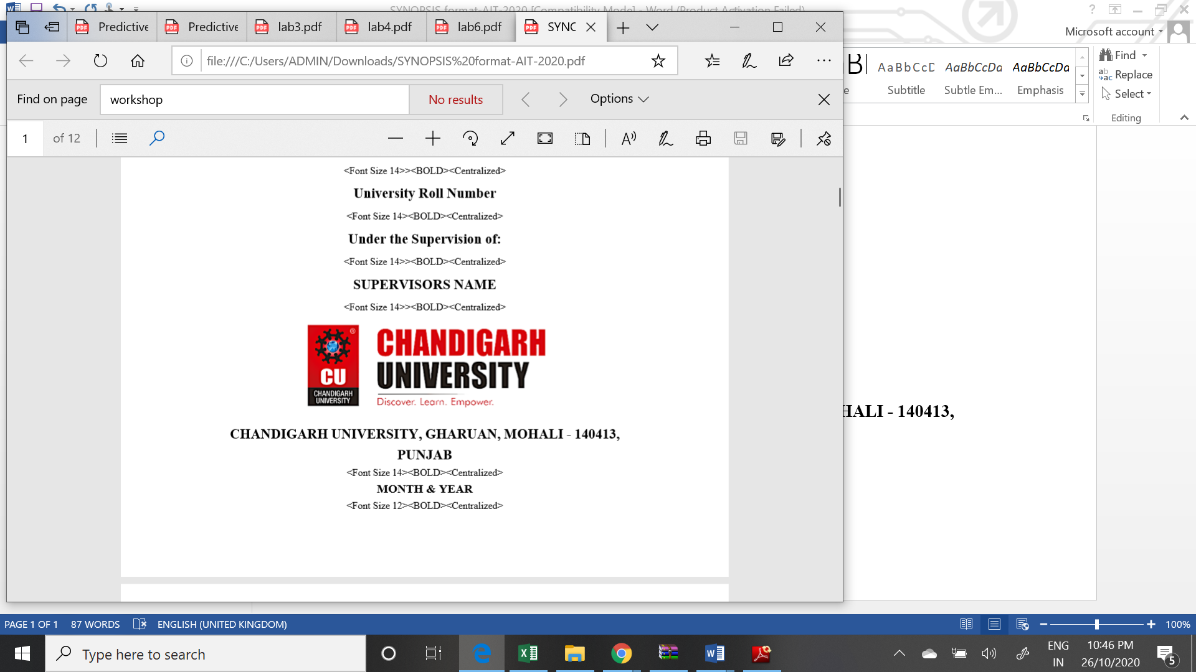

**CHANDIGARH** **UNIVERSITY,** **GHARUAN,** **MOHALI** **-** **140413,** **PUNJAB**

**December, 2020**

Name and signature of student(s)

Name and signature of Supervisor

# 

# PROJECT COMPLETION CERTIFICATE

## Project Title

This is to certify that the _**Tanweer Akhtar ________** has successfully completed the project work titled “ ___**Text Editor________________** ” *Submitted* *in* *the* *partial* *fulfilment* *for* *the* *award* *of* *the* *degree of* **BACHELOR** **OF** E**NGINEERING** **IN COMPUTER SCIENCE (INFORMATION SECURITY).**

This project is the record of authentic work carried out during the academic year

**2020**

**JYOTI MEHRA**

Project Guide

**Date:02/12\2020**

# DECLARATION

I the undersigned solemnly declare that the project report is based on my own work carried out during the course of our study under the supervision of_**Jyoti Mehra**. I assert the statements made and conclusions drawn are an outcome of my work. I further certify that the work contained in the report is original and has been done by me under the general supervision of my supervisor.

II. The work has not been submitted to any other Institution for any other degree/diploma/certificate in this university or any other University of India or abroad.

III. We have followed the guidelines provided by the university in writing the report.

IV. Whenever we have used materials (data, theoretical analysis, and text) from other sources, we have given due credit to them in the text of the report and giving their details in the references.

Tanweer Akhtar

19BCS3527

# ACKNOWLEDGEMENT

I have taken efforts in this project. However, it would not have been possible without the kind support and help of many individuals and organizations. I would like to extend my sincere thanks to all of them.

I am highly indebted to Chandigarh University for their guidance and constant supervision as well as for providing necessary information regarding the project & also for their support in completing the project.

I would like to express my gratitude towards my parents and my department for their kind co-operation and encouragement which help me in completion of this project.

THANKS AGAIN TO ALL WHO HELPED

**CONTEXT**

Chapter 1: Introduction to project

Chapter 2: Project Requirements (Software/Hardware requirements)

Chapter 3: Implementation Details (Algorithm, code)

Chapter 4: Output Analysis (screenshots)

**1.INTRODUCTION**

There will be times when you will want to edit textual files. Textual files are different from documents created by WordPad, Word, WordPerfect or some other word processing program in that they contain no imbedded codes. Editing these files with a word processing program can introduce special characters that make these files unusable. Instead, use Notepad which allows you to edit the file as pure text .Textual files will normally have a TXT file extension, but there are several special purpose files in Windows that must be pure text. Some of the more important of these include your CONFIG.SYS , AUTOEXEC.BAT , WIN.INI and SYSTEM.INI (These files existed in earlier version of Windows, but have been eliminated in Windows XP). You may get to the point of wanting to play with these files. If so, use Notepad to edit these and not WordPad as your system cannot use the resulting WordPad file. If you decide you want to create a webpage, but don't have an HTML editor, you will want to use Notepad so as not to introduce those nasty characters associated with WordPad, etc. In addition to having a tool to use in editing those special files on your system , learning Notepad can provide a good foundation for learning some of the other tools that come with Windows 95/98/ME/XP as well as a number of the applications that you may want to add to your system later. Notepad is simple tolearn but has some features in common with other programs.

# System development life cycle (SDLC)

* 1. System/Information Engineering and Modeling

* 1. Software Requirements Analysis

3.Systems Analysis and Design

4. Code Generation

5. Testing

6. Maintenance

### **System/Information Engineering and Modeling**

As software is always of a large system (or business), work begins by establishing requirements for all system elements and then allocating some subset of these requirements to software. This system view is essential when software must interface with other elements such as hardware, people and other resources. System is the basic and very critical requirement for the existence of software in any entity. So if the system is not in place, the system should be engineered and put in place. In some cases, to extract the maximum output, the system should be re-engineered and spruced up. Once the ideal system is engineered or tuned, the development team studies the software requirement for the system.

### **Software Requirement Analysis**

This is also known as feasibility study. In this phase, the development team visits the customer and studies their system. They investigate the need for possible software automation in the given system. By the end of the feasibility study, the team furnishes a document that holds the different specific recommendations for the candidate system. It also includes the personnel assignments, costs, project schedule, and target dates. The requirements gathering process is intensified and focused specially on software. To understand the nature of the program(s) to be built, the system engineer ("analyst") must understand the information domain for the software, as well as required function, behavior, performance and interfacing. The essential purpose of this phase is to find the need and to define the problem that needs to be solved.

### **System Analysis and Design**

In this phase, the software development process, the software's overall structure and its nuances are defined. In terms of the client/server technology, the number of tiers needed for the package architecture, the database design, the data structure design etc are all defined in this phase. A software development model is created. Analysis and Design are

very crucial in the whole development cycle. Any glitch in the design phase could be very expensive to solve in the later stage of the software development. Much care is taken during this phase. The logical system of the product is developed in this phase.

### **Code generation**

The design must be translated into a machine-readable form. The code generation step performs this task. If the design is performed in a detailed manner, code generation can be accomplished without much complication. Programming tools like Compilers, Interpreters, and Debuggers are used to generate the code. Different high level programming languages like C, C++, Pascal, and Java are used for coding. With respect to the type of application, the right programming language is chosen

### **Testing**

Once the code is generated, the software program testing begins. Different testing methodologies are available to unravel the bugs that were committed during the previous phases. Different testing tools and methodologies are already available. Some companies build their own testing tools that are tailor made for their own development operations.

### **Maintenance**

Software will definitely undergo change once it is delivered to the customer. There are many reasons for the change. Change could happen because of some unexpected input values into the system. In addition, the changes in the system could directly affect the software operations. The software should be developed to accommodate changes that could happen during the post implementation period.

# JAVA

**Java** is a [programming language](http://en.wikipedia.org/wiki/Programming_language) originally developed by [James Gosling](http://en.wikipedia.org/wiki/James_Gosling) at [Sun](http://en.wikipedia.org/wiki/Sun_Microsystems) [Microsystems](http://en.wikipedia.org/wiki/Sun_Microsystems) (which is now a subsidiary of [Oracle Corporation](http://en.wikipedia.org/wiki/Oracle_Corporation)) and released in 1995 as a core component of Sun Microsystems' [Java platform](http://en.wikipedia.org/wiki/Java_(software_platform)). The language derives much of its [syntax](http://en.wikipedia.org/wiki/Syntax_(programming_languages)) from [C](http://en.wikipedia.org/wiki/C_(programming_language)) and [C++](http://en.wikipedia.org/wiki/C%2B%2B) but has a simpler [object model](http://en.wikipedia.org/wiki/Object_model) and fewer [low-level](http://en.wikipedia.org/wiki/Low-level_programming_language) facilities. Java applications are typically [compiled](http://en.wikipedia.org/wiki/Compiler) to [byte code](http://en.wikipedia.org/wiki/Java_bytecode) ([class file](http://en.wikipedia.org/wiki/Class_(file_format))) that can run on any [Java Virtual](http://en.wikipedia.org/wiki/Java_Virtual_Machine) [Machine](http://en.wikipedia.org/wiki/Java_Virtual_Machine) (JVM) regardless of [computer architecture](http://en.wikipedia.org/wiki/Computer_architecture). Java is a general-purpose, concurrent, class-based, object-oriented language that is specifically designed to have as few implementation dependencies as possible. It is intended to let application developers "write once, run anywhere". Java is currently one of the most popular programming languages in use, and is widely used from application software to web applications.

The original and [reference implementation](http://en.wikipedia.org/wiki/Reference_implementation_(computing)) Java [compilers](http://en.wikipedia.org/wiki/Compiler), virtual machines, and [class](http://en.wikipedia.org/wiki/Library_(computing)) [libraries](http://en.wikipedia.org/wiki/Library_(computing)) were developed by Sun from 1995.

**Characteristics:-**

* Simple
* Object oriented
* Distributed
* Interpreted
* Robust
* Secure
* Architecture neutral
* Portable
* High performance

**JFC and Swing**

JFC and Swing is a part of java extension. JFC is short for Java Foundation Classes, which encompass a group of features to help people build graphical user interfaces (GUIs). The JFC was first announced at the 1997 Java One developer conference and is defined as containing the following features:

### **The Swing Components**

Include everything from buttons to split panes to tables

### **Pluggable Look and Feel Support**

It gives any program that uses Swing components a choice of looks and feels. For example, the same program can use either the Java look and feel or the Windows look and feel. We expect many more look-and-feel packages -- including some that use sound instead of a visual "look" -- to become available from various sources.

### **Accessibility API**

It enables assistive technologies such as screen readers and Braille displays to get information from the user interface.

### **Java 2DTM API (Java 2 Platform only)**

It enables developers to easily incorporate high-quality 2D graphics, text, and images in applications and in applets.

### **Drag and Drop Support (Java 2 Platform only)**

Provides the ability to drag and drop between a Java application and a native application. The Swing API is available in two forms:

* + - As a core part of the Java 2 Platform, Standard Edition (including versions 1.2, 1.3, and 1.4)

JFC 1.1 (for use with JDK 1.1)

**2.PROJECT REQUIREMENT**

Java IDE :- An integrated development environment is a software application that provides comprehensive facilities to computer programmers for software development. An IDE normally consists of at least a source code editor, build automation tools and a debugger

JDK:- The Java Development Kit is an implementation of either one of the Java Platform, Standard Edition, Java Platform, Enterprise Edition, or Java Platform, Micro Edition platforms released by Oracle Corporation in the form of a binary product aimed at Java developers on Solaris, Linux, macOS or Windows.

Operating System:- An operating system is system software that manages computer hardware, software resources, and provides common services for computer programs.

Free memory 512 mb:- To maintain large number of files we need space so it is required to have 512mb of storage capacity

Free RAM 256 mb:- To run the software smoothly, we have to provide sufficient storage in the primary memory.

**3.Implementation Detail**

**Algorithm of project:-**

To create a simple text editor:

**STEP 1:-**First, we will create a frame f titled “editor” and apply a metal look and feel and set an ocean theme in it.

**Step 2:-**We will add a text area and a menubar with three menu File, Edit, and Close.

**STEP 3:-**The “File” option has 4 menu items new, open, save and print.

**STEP 4:-**“Edit” has 3 menu items cut, copy and paste. We will add an action listener to all the menu items(using addActionListener() function) to detect any action.

**STEP5:-**We will add the menu items to the menu and menu to the menubar using add() function and we would add the menubar to the frame using addJMenuBar() function.

**STEP 6:-**We will add the text area to the frame using add function set the size of the frame to 500,500 using setSize(500,500) function and then display the frame using show function.

Here is how the functions of the menu will be invoked:

**STEP 7:-**On selecting the cut, copy, paste and print menu item the inbuilt functions of text area cut(), copy(), paste() and print() will be invoked.

**STEP 8:-**On selecting “save” menu item, a file chooser will get opened which will show the save dialog after selecting a file the filewriter(buffered writer) would write the contents of the text area to the file and close the file writer and buffered writer.

**STEP 9:-**On selecting “open” menu item, a file chooser will get opened which will show the open dialog after selecting a file a file reader and a buffered reader would read the file and set the text of the text area to the contents of the file.

**STEP 10:-**If the “new” menu item is selected the text of the text area will be set to blank. If “close” menu item is selected the frame is closed by using the function isVisible(false).

**Program:-**

package fgfdhds;

import java.awt.*;

import javax.swing.*;

import java.io.*;

import java.awt.event.*;

import javax.swing.plaf.metal.*;

import javax.swing.text.*;

class Editor extends JFrame implements ActionListener {

// Text component

JTextArea t;

// Frame

JFrame f;

// Constructor

Editor()

{

// Create a frame

f = new JFrame("editor");

try {

// Set metl look and feel

UIManager.setLookAndFeel("javax.swing.plaf.metal.MetalLookAndFeel");

// Set theme to ocean

MetalLookAndFeel.setCurrentTheme(new OceanTheme());

}

catch (Exception e) {

}

// Text component

t = new JTextArea();

t.setBackground(Color.BLACK);

t.setFont(new Font("Times New Roman", Font.BOLD,30));

t.setForeground(Color.WHITE);

// Create a menubar

JMenuBar mb = new JMenuBar();

mb.setBackground(Color.GREEN);

// Create amenu for menu

JMenu m1 = new JMenu("File");

// Create menu items

JMenuItem mi1 = new JMenuItem("New");

JMenuItem mi2 = new JMenuItem("Open");

JMenuItem mi3 = new JMenuItem("Save");

JMenuItem mi9 = new JMenuItem("Print");

// Add action listener

mi1.addActionListener(this);

mi2.addActionListener(this);

mi3.addActionListener(this);

mi9.addActionListener(this);

m1.add(mi1);

m1.add(mi2);

m1.add(mi3);

m1.add(mi9);

// Create amenu for menu

JMenu m2 = new JMenu("Edit");

// Create menu items

JMenuItem mi4 = new JMenuItem("cut");

JMenuItem mi5 = new JMenuItem("copy");

JMenuItem mi6 = new JMenuItem("paste");

// Add action listener

mi4.addActionListener(this);

mi5.addActionListener(this);

mi6.addActionListener(this);

m2.add(mi4);

m2.add(mi5);

m2.add(mi6);

JMenuItem mc = new JMenuItem("close");

mc.addActionListener(this);

mc.setBackground(Color.GREEN);

mb.add(m1);

mb.add(m2);

mb.add(mc);

f.setJMenuBar(mb);

f.add(t);

f.setSize(500, 500);

f.show();

}

// If a button is pressed

public void actionPerformed(ActionEvent e)

{

String s = e.getActionCommand();

if (s.equals("cut")) {

t.cut();

}

else if (s.equals("copy")) {

t.copy();

}

else if (s.equals("paste")) {

t.paste();

}

else if (s.equals("Save")) {

// Create an object of JFileChooser class

JFileChooser j = new JFileChooser("f:");

// Invoke the showsSaveDialog function to show the save dialog

int r = j.showSaveDialog(null);

if (r == JFileChooser.APPROVE_OPTION) {

// Set the label to the path of the selected directory

File fi = new File(j.getSelectedFile().getAbsolutePath());

try {

// Create a file writer

FileWriter wr = new FileWriter(fi, false);

// Create buffered writer to write

BufferedWriter w = new BufferedWriter(wr);

// Write

w.write(t.getText());

w.flush();

w.close();

}

catch (Exception evt) {

JOptionPane.showMessageDialog(f, evt.getMessage());

}

}

// If the user cancelled the operation

else

JOptionPane.showMessageDialog(f, "the user cancelled the operation");

}

else if (s.equals("Print")) {

try {

// print the file

t.print();

}

catch (Exception evt) {

JOptionPane.showMessageDialog(f, evt.getMessage());

}

}

else if (s.equals("Open")) {

// Create an object of JFileChooser class

JFileChooser j = new JFileChooser("f:");

// Invoke the showsOpenDialog function to show the save dialog

int r = j.showOpenDialog(null);

// If the user selects a file

if (r == JFileChooser.APPROVE_OPTION) {

// Set the label to the path of the selected directory

File fi = new File(j.getSelectedFile().getAbsolutePath());

try {

// String

String s1 = "", sl = "";

// File reader

FileReader fr = new FileReader(fi);

// Buffered reader

BufferedReader br = new BufferedReader(fr);

// Initilize sl

sl = br.readLine();

// Take the input from the file

while ((s1 = br.readLine()) != null) {

sl = sl + "\n" + s1;

}

// Set the text

t.setText(sl);

}

catch (Exception evt) {

JOptionPane.showMessageDialog(f, evt.getMessage());

}

}

// If the user cancelled the operation

else

JOptionPane.showMessageDialog(f, "the user cancelled the operation");

}

else if (s.equals("New")) {

t.setText("");

}

else if (s.equals("close")) {

f.setVisible(false);

}

}

// Main class

public static void main(String args[])

{

Editor e = new Editor();

}

}

**4. Output Analysis (screenshots)**

**SNAPSHOTS Analysis:-**

## Main window

This is the GUI of text editor it includes the dock under the menu bar and text space for editing the text. The look and feel is default look of Operating system.

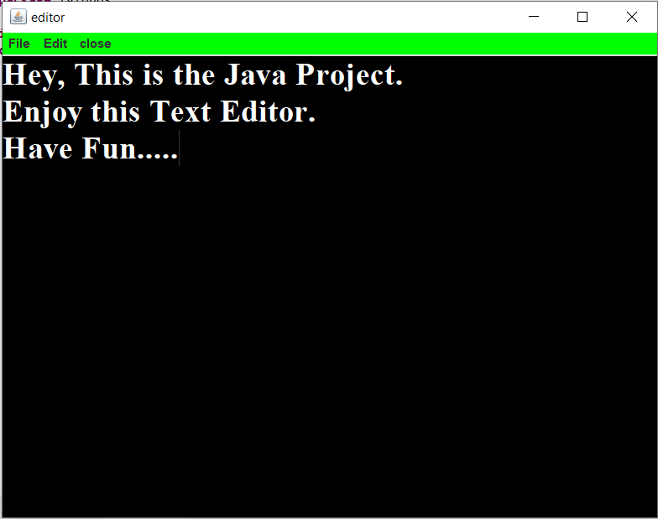

## 2.Opening a file

This window appears when we click on the open option on the Dock or in the file menu The file menu is created using JMenu class.

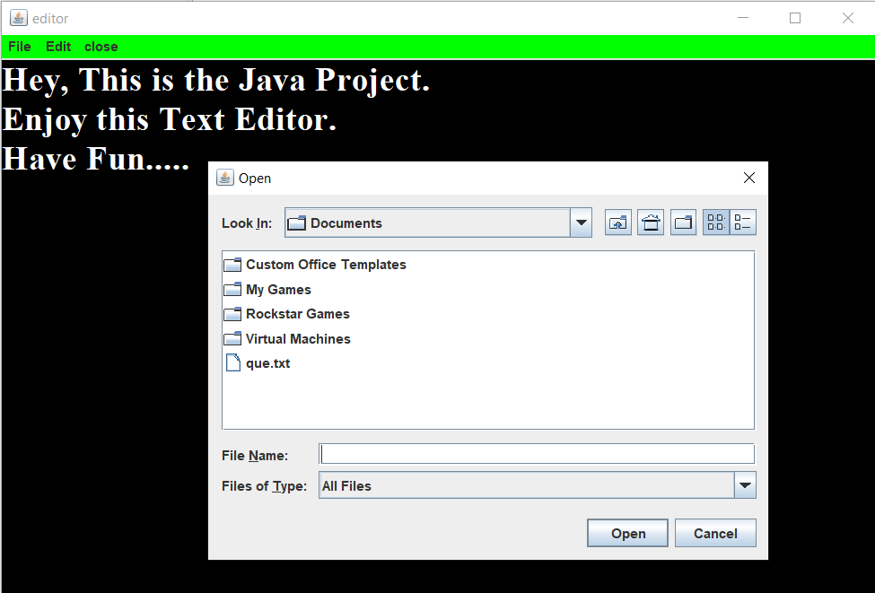

## 3.Saving a file

## This window appears when we want to save the file. The shortcut Ctrl+s do not work here so we can do it using file menu or option on the Dock.

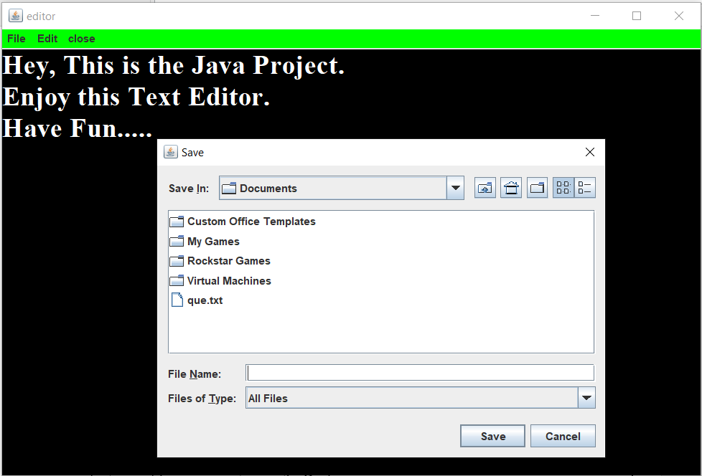

**4.Print a file**

## This window appears when we want to print the file. The shortcut Ctrl+p do not work here so we can do it using file menu or option on the Dock.

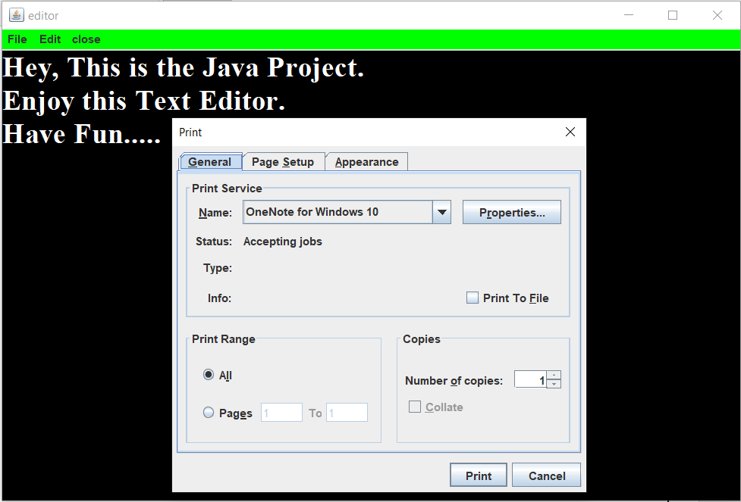

**5.Cut , Copy , Paste :-**

## This window appears when we want to cut , copy and paste the file. The shortcut Ctrl+x, Ctrl+c, Ctrl+v, do not work here so we can do it using file menu or option on the Dock.

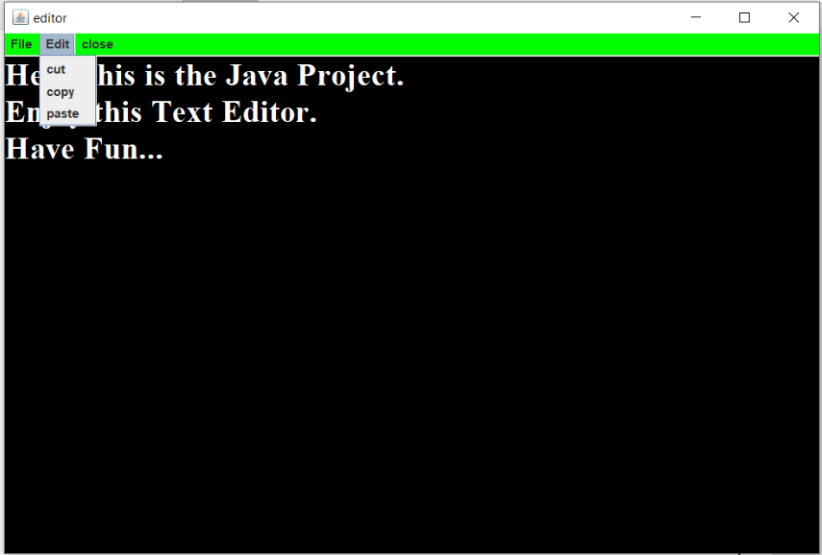

# Conclusions

This project that I undertook was truly a very rewarding experience for me in more than one way. It has given a big thrust to my technical knowledge as prospective Software professional. It has also helped me enhance my skills on the personal front.

And I feel extremely satisfied by the fact that I have managed to develop the project of course with equal contribution from my team members. I think I have exploited the opportunity that came my way to the fullest extent by increasing my technical know-how and also gaining the valuable work experience apart from studying the other subjects in our curriculum.

|  |
| --- |
|  |
|  |  |